Lab-4 Python Programming Basics Assignment

Name: Ketan Goud
Reg No: 220905260
Roll No: 39
Section: D D2

1. Write a python program to select smallest element from a list in an expected
linear time.

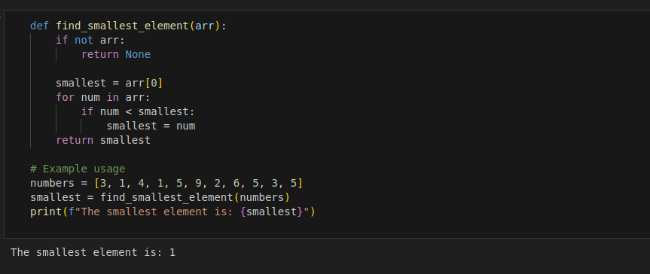
2. Write a python program to implement bubble sort.

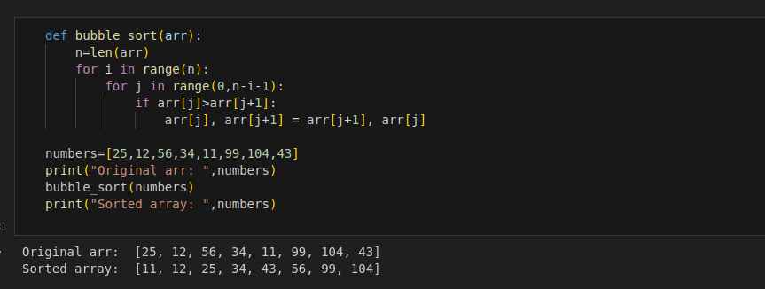

3. Write a python program to multiply two matrices

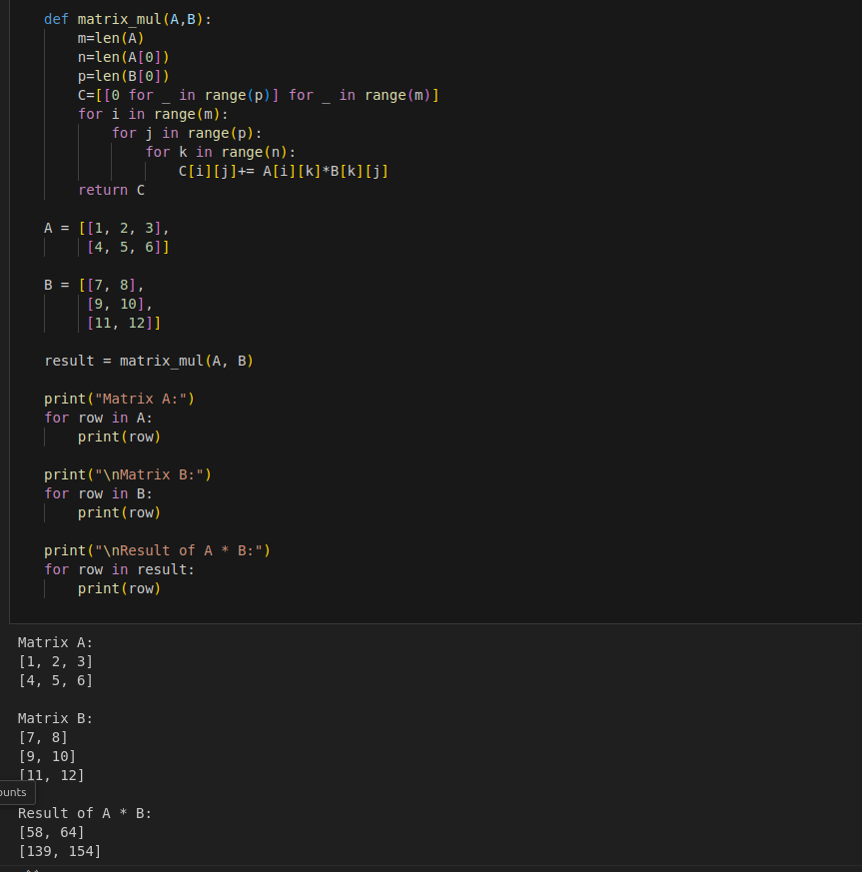

4. Write a Python class to find validity of a string of parentheses, '(', ')', '{', '}', '[' and ']. These rackets must be close in the correct order, for example "()" and "()[]{}" are valid but "[)", "({[)]" and "{{{" are invalid.
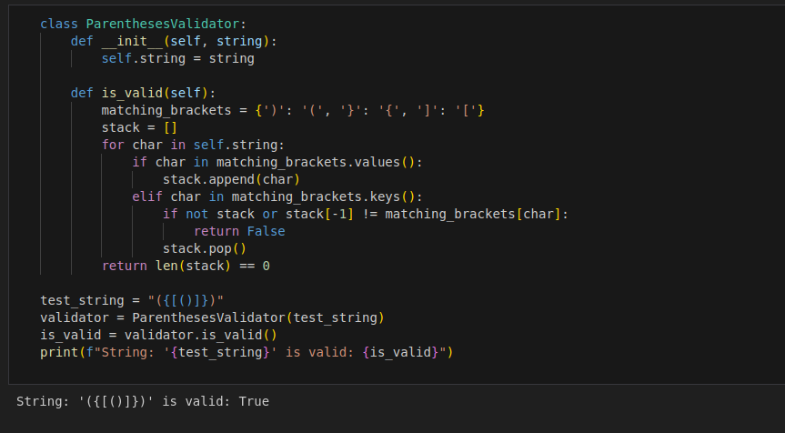
5. Write a Python class to reverse a string word by word.

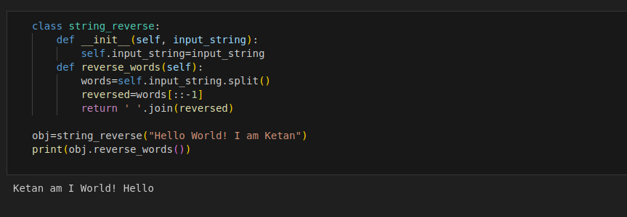
6. Write a Python class named Circle constructed by a radius and two methods
which will compute the area and the perimeter of a circle.

